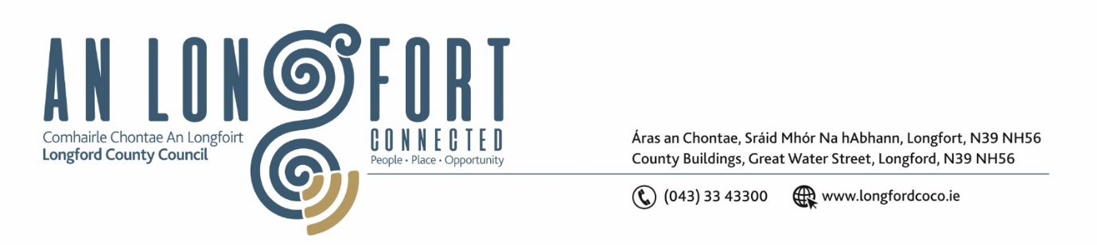

**LONGFORD MUNICIPAL DISTRICT**

***Please note meeting will be held in the Council Chamber, Aras an Chontae and via Microsoft Teams***

**8 October 2024**

**To: Each Member of Longford Municipal District.**

**Dear Member,**

You are requested to attend the Meeting of Longford Municipal District to be held in **the Council Chamber, Aras an Chontae** and **via Microsoft Teams** on **Tuesday, 15 October 2024 at 11 am** to transact business, as set out on the agenda hereunder.

**Yours sincerely**,

_______________

**Claire McNabola**

**Meetings Administrator**

**AGENDA**

Prayer before meeting.

**1.** Confirmation of Minutes:

1. Longford Municipal District Meeting held on 23 July 2024 – enclosed.
2. Longford Municipal District Committee Meeting held on 23 July 2024 – enclosed.
3. Longford Municipal District Committee Meeting held on 6 August 2024 – enclosed.
4. Longford Municipal District Committee Meeting held on 13 August 2024 – enclosed.
5. Longford Municipal District Committee Meeting held on 28 August 2024 – enclosed.
6. Longford Municipal District Meeting on 24 September 2024 – enclosed.

**2.** Matters arising from Minutes.

**3.** Declaration of Interest by Members.

**4**. Consideration of Draft Standing Orders for Longford MD

**5.** Management Report – enclosed

**6**. Consideration of Part 8 – No. 119 Lamagh, Newtownforbes, Co. Longford

**7.** Longford Town Area Plan

**8.** 2025-2027 Multi Annual Improvement Programme

**9.** THRIVE project

**10.** Notice of Motions set out hereunder:

**Councillor Uruemu Adejinmi**

1. I am calling for review of the Local Improvement Scheme (LIS) to ensure that during assessment of LIS applications received, each Municipal District is given an annual allocation under the scheme.

**Councillor Martin Monaghan**

1. I call on Longford County Council to tidy the footpath and cut back the hedging between the Red Cow roundabout and the Leo Casey roundabout, this part of the bypass is in urgent need of attention.
2. I call on Longford County Council to repair the road surface at the roundabout at McDonalds as it is in very poor condition.

**10.** Date and Time of next meeting